Shabbos Stories for
Parshas Emor 5781
Volume 13, Issue 35 19 Iyar/May 1, 2021
Printed L’illuy nishmas Nechama bas R’ Noach, a”h

For a free subscription, please forward your request to keren18@juno.com
Past stories can be found on the website ShabbosStories.com

Volcanoes on the Sidewalk
By Ari Ben-Ami and illustration by Yocheved Nadell

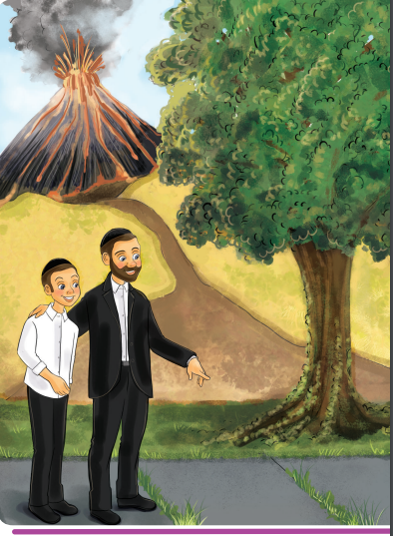

“Totty, Totty!” said Shimmy breathlessly as he ran into the house after school.
“Hi Shimmy!” Totty said with a smile, looking up from the sefer he was holding. “What’s wrong? Why are you so out of breath?”
“Totty,” Shimmy said, still trying to catch his breath. “We need to go to Hawaii. Can you buy tickets right now?”
Totty almost dropped his sefer. “What? Hawaii? Why? What are you talking about?”
“Ari Holtzbacher just came back from Hawaii!” Shimmy gushed. “The whole family flew there for his little brother’s upsherin. And he was telling us about all of the amazing things they have there: the crystal blue ocean that goes on for miles, tropical rain forests, and volcanoes! Volcanoes, Totty! With real actual boiling hot lava flowing down from them into the ocean. Can you imagine? We have to go right away!”

Why Should We Waste Money on a Trip to Hawaii?
“But Shimmy,” Totty said, “I don’t have a hundred billion dollars like Anshel Holtzbacher. And even if we did have that kind of money, why would we waste it on a trip to Hawaii?”
“But don’t you always tell us how important it is to spend time looking at and admiring Niflaos HaBorei? Didn’t Rav Avigdor Miller speak about that a lot? Something that important is surely worth spending extra money, just like buying a beautiful lulav and esrog.”
“Oy Shimmy,” said Totty with a smile. “I love the way you think. But let’s think about this week’s parsha for a minute.”
“This week’s Parsha?” Shimmy asked, slightly confused. “It talks about tzoraas. Oh do you mean because the Metzora has to go out of town? Does that mean traveling is only something people who talk loshon hora do?”
“Not exactly, Shimmy,” said Totty. “Come, let’s go for a walk.”
Totty and Shimmy walked out the front door and down the street. After a minute, Totty stopped. “We don’t need to go to Hawaii to see oceans and volcanoes,” he said, pointing at the sidewalk. “Everything we need is right here.”

Where is the Ocean and Where is the Volcano?
Now Shimmy was really confused. There were no oceans and volcanoes on the sidewalk. There was just a faded hopscotch court that one of the neighbor kids had drawn with chalk.
“I don’t see anything,” Shimmy said.
“Think for a second about what the metzora brings along with his korbon.” said Totty.
“Oh,” Shimmy said. “He brought erez and eizov - I think that was wood from two different trees.”
“Good answer,” replied Totty, “but not exactly. You see eitz erez is cedar wood - and a cedar tree is indeed a big huge tall tree. But eizov is moss, just like you see on the trunk of that tree over there. Why did the Torah tell the metzora to bring these two things?
“So Rav Miller explains that the reason the metzora got punished with the terrible tzoraas is because he forgot to stop and see the greatness of Hashem all around him. He just wasted his time with silly jokes and loshon hora, when instead he could have been admiring all of the wonderful things Hashem put into this world.

Failure to Look at the Wonders of Hashem
“That’s why he needs to bring erez and eizov. Because he failed to look at the wonders of Hashem’s big strong trees and didn’t even pay attention to how amazing these little moss plants are. Do you know that moss seeds - or spores - are so tiny that they get carried by the wind all around the world and everywhere where it’s damp and not too sunny they grow?
“That’s why the moss always grows on the north side of trees in this part of the world - because that’s the side of the tree that gets the least sun, so it is wetter and has more water to support the moss!”
Totty pointed down at the sidewalk once more. "Now look again, Shimmy, and tell me what you see."
“Wow,” said Shimmy. "Look at that grass poking up from the cracks in the sidewalk. I’m sure they didn’t put grass seeds there - there doesn’t look like there is even any soil there!”

“Isn’t it Amazing!”
“I know, isn’t it amazing?” Totty said. “But this grass is actually from the grass you see on the field here next to the sidewalk. Grass may look small, but its roots grow super deep - grass roots can even be taller than you or me! And the roots spread out under the ground and then they push up new blades of grass everywhere.
“Even when there’s a rock-hard sidewalk, they find the tiniest cracks and then push themselves through. And then these little tiny blades of grass help convert the poisonous carbon dioxide that comes out of our lungs back into refreshing clean oxygen for us to breathe!”
“Incredible - such Niflaos HaBorei!” said Shimmy, looking around, and for the first time noticing all of the different types of plants, trees, and birds around them. “It’s like we have our very own Hawaii right here - and we only need to walk a few feet to get there!”

Reprinted from the Parshas Tazria-Metzora 5781 email of Junior Avigdor, a part of Toras Avigdor based on the teachings of Rabbi Avigdor Miller, zt”l.

Learning from a Baby

A few years ago, a couple in Bnei Brak was blessed with a new baby girl. After the baby was born, she would not stop crying and would not nurse from her mother or take any bottles. This concerned the head nurse, who looked in the baby’s mouth and discovered that her lip and tongue were attached. This was a very severe case of this particular deformity. The nurse set up a feeding tube to give the baby necessary nutrients.
Right away, the parents discussed between themselves that though this was a tragic occurrence, it is from Hashem and clearly symbolic. Since the defect occurred in the baby’s mouth, they took upon themselves to strengthen their shemirat halashon—guarding one’s tongue and vowed to be more careful and refrain from speaking lashon hara. They also took upon themselves to learn two halachot a day of shemirat halashon and to make sure not to speak or hear lashon hara as a zechut for the refuah shelemah of their newborn baby.

Searching for the Best Surgeon
The parents then researched who was the best surgeon to perform this complicated procedure to fix their daughter. The parents brought their baby to the surgeon for the appointment a week after they took upon themselves to refrain from speaking lashon hara. The surgeon looked into the baby’s mouth. He looked and looked inside with a serious expression, not saying a word, which made the parents anxious. Finally, the surgeon said, “I really don’t know why you are here, there is absolutely nothing wrong with your daughter’s mouth. Her tongue and lips are perfect, exactly the way they should be.”

A Frightening Idea
Rabbi Frand brings down a frightening chiddush—idea from the Chovot HaLevavot. The idea is that if Reuven was to slander Shimon, it is said that all of Reuven’s mitzvot and merits that he accumulated up until that point will be transferred over to Shimon, and all of Shimon’s sins will be transferred to Reuven. The Chovot HaLevavot goes as far to tell a story about how Shimon sent Reuven a fruit basket as a gift for Reuven saying lashon hara about him, to thank and repay Reuven for transferring all his merits over to Shimon.

Reprinted from the Parshat Tazria-Metsora 5781 email of Jack E. Rahmey based on the teachings of Rabbi Amram Sananes.

The Rosh Yeshivah
And the Mailbox

Tefilos in the Manchester Yeshivah were meticulous and lengthy, yet long after the last Kaddish for Maariv was over, the Rosh Yeshivah, Rav Yehuda Zev Segal, zt”l, would finally complete his Davening.
A student would then give the Rosh Yeshivah a ride home. However, for Rav Segal, the ride was not a gap in the day’s schedule. He got into the car carrying a bundle of letters to mail. It used to be that when the boys had letters to mail, they would give their letters to a Bachur named Eliezer to mail for them. One time, when they brought the letters to Eliezer, Rav Yehuda Zev asked if he could take them instead. The Bachurim hesitated. Surely, this wasn’t Kavod for the Rosh Yeshivah! But who were they to argue?
Even the Yeshivah’s driver asked if he could go out into the cold night instead of the Rosh Yeshivah to mail the letters, but Rav Yehuda Zev became very animated, and exclaimed, “I would give you a million pounds for this Mitzvah! Mailing the letters is a Chesed for the Bachurim, and it brings great joy to their parents, who live far away.”
So, every evening, the car would stop by the mailbox on the side of the road, and the Rosh Yeshivah would emerge and mail the letters. He would say “Hineni Muchan U’Mezuman… Behold I am prepared to do a Mitzvah of Chesed!” and he would mail the letters. When he got back in the car, he would say, “Look how Hashem gives Olam Haba away! For an act that is so small, you get so much!”
Reprinted from the Parshas Tazria-Metzora 5781 email of Torah U’Tefilah
Hillel and the Aggravating Erev Shabbos Questionnaire

The Gemara (Shabbos 30b) discusses the patience and tolerance of the Sages, who remain silent when they were confronted by those who instigate or make nonsensical comments. It was taught in a Braisa that one should always be patient like Hillel, and the Gemara relates a story.
There were two people who made a bet with each other, that anyone who would be able to aggravate Hillel to the point that he reprimands them, will win four hundred zuz.
One of them said, “I will aggravate him.” He waited for Erev Shabbos, and as Hillel was washing his hair, he went to Hillel’s front door and demanded, “Where is Hillel? Where is Hillel?”

“My Son, How Can I Help You?”
Hillel wrapped himself in his garment and went out to greet him, and said, “My son, how can I help you?”
The man said, “I have a question to ask.”
Hillel responded, “Ask, my son, ask.”
The man said, “Why are the heads of the people from Bavel oval-shaped?” He was attempting to insult Hillel, who was from Bavel. Hillel said to him, “My son, you have asked a significant question. The reason is because they do not have clever midwives. They do not know how to shape the child’s head at birth.”
The man left and waited a little, and then a short while later, he returned to look for Hillel. He again demanded, “Where is Hillel? Where is Hillel?” Again, Hillel wrapped himself in his garment and went out to greet him. Hillel said to him, “My son, what do you seek?”
The man said, “I have a question to ask.”
Hillel replied, “Ask, my son, ask.”

A Question about the Residents of Tadmor
The man asked, “Why are the eyes of the residents of Tadmor bleary and hazy?”
Hillel said to him, “My son, you have asked a significant question. The reason is because they live among the sands and the sand gets into their eyes.” Once again, the man left, waited a little, and then returned, and said, “Where is Hillel? Where is Hillel?” Again, Hillel wrapped himself and went out to greet him.
He said, “My son, what would you like?”
The man said, I have a question to ask.
Hillel replied, “Ask, my son, ask.”
The man said, “Why do people from Africa have wide feet?”
Hillel said to him, “You have asked a significant question. The reason is because they live in marshlands and their feet are widened to enable them to walk through those swampy areas.”
The man said, “I have many more questions to ask, but I am afraid to, so that I don’t get you angry.”
Hillel sat down before him and he said, “All of the questions that you have to ask, ask them.”

The Questionnaire Gets Angry
The man got angry and said, “Are you Hillel, the one people call the ‘Nasi of Yisroel’?”
Hillel replied, “Yes.”
The man said, “If it is you, then may there not be many like you in Israel!” Hillel responded, “My son, for what reason do you say this?”
The man answered, “Because I lost four hundred Zuz because of you!” Hillel said to him, “Watch yourself in the future and avoid situations like this. It is worth it for you to lose four hundred Zuz, and even to lose another four hundred Zuz on account of me, but Hillel will not get upset for any reason!”

Reprinted from the Parshas Tazria-Metzora 5781 email of Torah U’Tefilah as compiled by Rabbi Yehuda Winzelberg.
The Talmid Chacham
And The Secular Doctor

Rabbi Dovid Sutton notes that when one puts his life at risk for a Mitzvah, Hashem repays that person back. He relates the following story which illustrates how one man’s sacrifice for Shabbos rewarded him, and resulted in a Kiddush Hashem.
A Talmid Chacham (Torah scholar) in Eretz Yisroel did not have much money, and his son took seriously ill on a Shabbos, R”L. He desperately needed a doctor, and there happened to be an excellent doctor, who was a secular Jew, who lived down the block from him.
The doctor was called over to the man’s house and agreed to treat the boy. However, he demanded that he be given a check as payment immediately, before he treated the child. The doctor said, “I don’t trust religious Jews. I will tend to your son only if you give me a check for 500 Shekel right now.”
Halachah clearly establishes that human life overrides Torah law, and so, the father wrote a check in an unusual manner (using a Shinui), and handed it to the doctor.
The doctor looked at the check, and noticed that it was written for 1,000 Shekel. The doctor said, “Maybe you didn’t hear me correctly. I asked for 500 Shekel, not 1,000. Besides, looking around your apartment, it does not appear as though you can afford to pay me extra.”
The Talmid Chacham explained, “To write a check for 500 Shekel, I would have to write three words in Hebrew, ‘Chameish Mei’os Shekel’ (500 Shekel), whereas writing 1,000 Shekel required writing just two words, ‘Elef Shekel’ (1,000 Shekel). In order to minimize the Chilul Shabbos, the desecration of Shabbos, I am prepared to double the amount you asked for.”
The doctor was astounded. He had never seen anything like this in his life! Here was a poor person paying an extra 500 Shekel in order to write ONE word less on Shabbos.
The doctor put the check in his pocket. He took out 500 Shekel and set it down on the table as change, treated the sick child, and brought the check home to show his wife.
After Shabbos, the doctor returned to the Talmid Chacham’s home and said, “I was so moved by what you did today, and I decided that I wanted to learn more about Shabbos and Judaism.” The Talmid Chacham began studying with him, and ultimately, the doctor became a Ba’al Teshuvah!
Reprinted from the Parshas Tazria-Metzora 5781 email of Torah U’Tefilah as compiled by Rabbi Yehuda Winzelberg.
The Steipler Gaon’s Lulav

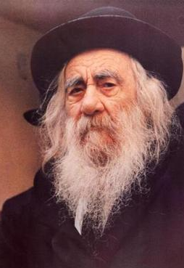

Before Sukkos, the Steipler Gaon, ZT”L, once went into a store that sold lulavim. He checked all the lulavim in the store, but did not find any that were satisfactory to him. He walked out of the store but then suddenly returned. He again searched through them, and this time took one and paid for it.
When he walked outside, he explained to his relative who was with him, “If I were to walk out of the store without purchasing a lulav, it is likely that a rumor would have started that Rabbi Kanievsky didn’t find even one lulav that was kosher in this store. Then, other people would not enter and it would come out that I caused this person a loss of money. Therefore, I made sure to buy a lulav.”

Reprinted from the Parshas Tazria-Metzora 5781 email of Torah Sweets Weekly (edited by Mendel Berlin)

Rising from the Flames
By Raquel Kirszenbaum

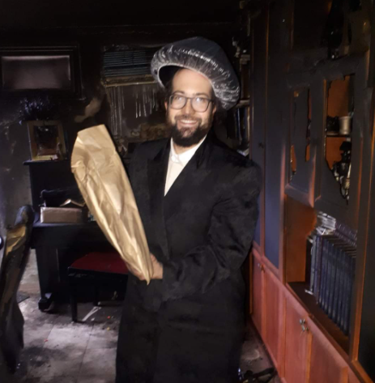
Raquel's husband standing in their burnt out apartment, holding a megillah that was untouched.

Raquel Kirszenbaum is a beloved teacher in Neve and a sought-after speaker. Raquel shares how she dealt with the aftermath of a devastating house fire eruv Pesach, on the day she gave birth.
I gave birth to my second child and became instantly homeless.
I was coming out of the delivery room when my husband was called by people saying that there were firemen in our apartment. I thought it was just a little fire, maybe there'd be a bit of smoke damage. It was only the next day when I saw pictures and realized it was all gone.
We lost everything we’d built, our whole lives were gone instantaneously. It’s not the material loss. It was the lack of stability. We became homeless. We became totally dependent on others and had no idea what we were going to do next.
I had a newborn and a 2-year-old. It was Thursday and Shabbos was Pesach. It was the biggest test of my life. At first, I thought, not only did we have to wait and struggle to have children, but I give birth and my home burns down?! We chose to name our child Shira Bracha because, while I didn’t feel it at the time, I knew we wanted to face the challenge with emunah.
Shira is the highest level of prayer, where it’s all emunah because you see everything as a bracha.

The Hashgacha of a Difficult Experience
If it had to happen, at least Hashem made it happen when I was giving birth. It would have been traumatic to experience. Also, it made people more empathetic, especially as it was eruv Pesach. Because I had just given birth, my husband took care of everything and he was so calm. So even though the experience was harder, the outcome was better.
I always tell my students that from bitterness comes the sweet, the darkest hour is before dawn. The amount of chessed we experienced was so impressive. I didn’t realize I was so loved. It was eruv Pesach and people took in my clothes to wash, girls came over to sort through the apartment, Rabbi Nissel came eruv Pesach to help salvage what was left! The community was amazing. So many people wanted to help. It was worth it to live through such a difficult time to see such chessed.
We had needed to move before the fire. I knew we had until June, maybe July to stay, but I kept doing the math and we could not afford to move. I thought it was impossible. How could we ever afford the space we needed? Yet Hashem has ways no-one could ever imagine. Let G-d surprise you. You thought of all the possibilities and logic, but you forgot that Hashem is not limited to the possibilities you can imagine, to logic.

My Students Came to the Rescue
My students created a fund and raised money. It was amazing.
After only 6 months were settled into a new place. We were stable, we’d been able to save a lot of our things. It was a neis. I wouldn’t say it’s the greatest neis because it was only a material salvation. There was a lot of crying during the first few weeks.
But I was able to look back and see Hashem guiding every stage, how we were worried about finding a short-term rental, about buying new furniture when we didn’t know if it would fit into the next apartment, how a landlord cancelled the day before we were supposed to move in–it all worked out for the best, we found a better short-term rental and our furniture fit into our new place - and it made a huge Kiddush Hashem.
So many people heard our story and were inspired. Hashem sorted out every detail, I can’t even explain how much hashgachah there was.

Reprinted from the Neve Yerushalayim Alumnae email of April 16, 2021.

The Netziv and the Doctor

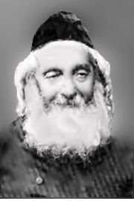

R’ Naftoli Tzvi Yehuda Berlin, the Rosh Yeshiva of Volozhin known by the acronym, Netziv, never went to the doctor when he was sick. Once, though, when he experienced a prolonged period of not feeling well, he acquiesced to his family’s urging and let a doctor visit.
After the exam, the doctor gave him a prescription and the Netziv thanked him. No sooner did the doctor leave than the Netziv tore up the scrip.
“What are you doing?” asked his incredulous family.
The Netziv explained that instead of going to a doctor when something hurt him, he would think about which mitzvos are associated with that limb. He would then examine which of those mitzvos he has been lax in and make an effort to repair his wrongdoing, thereby strengthening that body part.
However, this time he could not identify exactly which part of his body caused him to feel weak. Once the doctor identified it, he no longer needed he doctors medicine. He would now cure it the way he always cured his own ailment, through teshuva. – Source: revach.net

Reprinted from the Parshas Tazria-Metzora 5781 email of Migdal Ohr.
Rabbi Eliezer Silver and the Mikveh for the Refugees

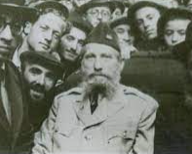
Rabbi Eliezer Silver, zt”l visiting survivors of the Holocaust

During World War II, the American government enacted a rescue commission known as the War Refugee Board which achieved a few notable results (although not as much as it could have), including the rescue of over 100,000 Jews and the distribution of vital relief services when the war ended.
In one unique instance, roughly 1,000 refugees were brought from Italy to Fort Ontario, an abandoned army base near Oswego, New York. Vaad Hatzalah, the Orthodox relief organization, offered a wide range of support services, a model for its postwar efforts.

Three Hundred Torah-Observant Jews
Among the refugees were 300 Torah-observant Jews. The Vaad promptly met their basic needs: kosher food, talis, tefillin and a shul in which to pray. At first, only Orthodox refugees registered for kosher food. Yet, as word of its superior quality spread, the number of registrants doubled. How could the Vaad refuse? After all, Jews wished to eat kosher. The Vaad was delighted.
In time, a second kosher kitchen was established, and a Talmud Torah for the children. The camp’s needs increased daily and the refugees requested an eruv in order to carry on Shabbos. The Vaad had no difficulty taking care of that need to the great appreciation of the refugees.
The next request, however, was not as simple - the Jews insisted that they need a Mikveh, to ensure spiritual sanctity in their homes. The Vaad was happy to oblige but before they could anything, they needed to explain the concept and importance of a Mikveh to Mr. Joe Smart, the Christian camp director. Without his approval, nothing could be done.
The Vaad asked R’ Eliezer Silver zt”l, a ranking member of the Vaad and the chief rabbi of Cincinnati, Ohio, who had come to visit the refugees and offer them encouragement, to represent them in their attempt to procure permission for this endeavor.

Translating the Word Mikveh into English
R’ Laizer was eager to be of assistance. The word Mikveh needed to be translated into English, and one way to do this was to use the word ritualarium, which had been coined earlier while building Boro Park’s first mikveh.
“A ritualarium,” R’ Silver explained to Joe Smart in his heavily accented English, “is a bath where Jewish men and women immerse themselves for religious purposes. Separately, of course.”
Smart nodded knowingly. “What you need is a swimming pool,” he said chirpily.
R’ Laizer shook his head indicating that a swimming pool was not acceptable. He decided to try to explain the concept of a Mikveh, by showing Smart how to build one.
“Okay. First,” he said, “the Talmud requires that a Mikveh must have at least 40 se’ah (a minimum of 648 liters) of water.” Smart shrugged unknowingly. He had never heard of a “se’ah.” But R’ Laizer didn’t notice.
“Also, the space is measured in amos (cubits).” The camp director looked around, helplessly lost in the terminology, searching desperately for a translator. But R’ Laizer would not let him go. “Amos ... you know, forearms, forearms. It’s measured in cubits - about the length of a forearm.” He stretched out his right arm as if to demonstrate the exact dimension in true life.

No Idea about What the Rabbi was Talking About
Joe Smart immediately demurred, taking the matter on faith. “Rabbi, it’s okay. Amos .... cubits, that’s fine.” Joe realized that the diminutive rabbi had already drawn a crowd. And he still had no idea what the man was talking about! “Okay,” R’ Laizer said, “now the water. A Mikveh needs natural water.” He began making flowing gestures with his hands. Displaying enormous patience, Smart smiled, “All water is natural. You want us to pump water in for your Mikveh, right?”
“No, no,” R’ Silver shouted, arms flailing in all directions. “Still, natural water. A Mikveh cannot have water collected from a pipe. The water must be obtained from the sky or a river. It has to be still and natural.”
Joe Smart sighed and gave up. He could not grasp the details and really had no clue what this eminent rabbi was talking about. Shrugging, he motioned to a couple of army engineers standing nearby. “Do whatever the rabbi says,” he said, and slowly backed away.
The engineers had not been part of the conversation before and now ambled over to the short man with the top hat and long coat. Before they had even reached him, R’ Laizer launched into a discourse on amos, forearms and natural water, to the utter surprise and bewilderment of the new arrivals. R’ Eliezer Silver persevered, and in two weeks there was a Mikveh!

Reprinted from the Parshas Tazria-Metzora 5781 email of Torah Tavlin (compiled by Rabbi Dovid Hoffman).

An Italian Bronze Tankard-Form Charity Container

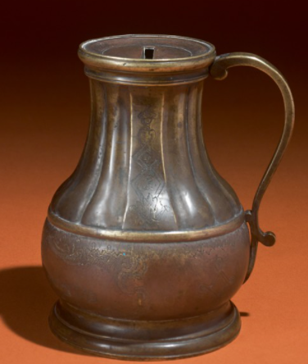
This 18th Century Judaica item from the Arthur and Gitel Marx Collection sold at 2019 Southeby’s Auction for $11,875.

